PROJECT

Interfacing Stepper Motor with Arduino Uno

HC 05/06 works on serial communication. The Android app is designed to send serial data to the Arduino Bluetooth module when a button is pressed on the app. The Arduino Bluetooth module at the other end receives the data and sends it to the Arduino through the TX pin of the Bluetooth module (connected to RX pin of Arduino). The code uploaded to the Arduino checks the received data and compares it. If the received data is 1, the LED turns ON. The LED turns OFF when the received data is 0. You can open the serial monitor and watch the received data while connecting.

Circuit and Working

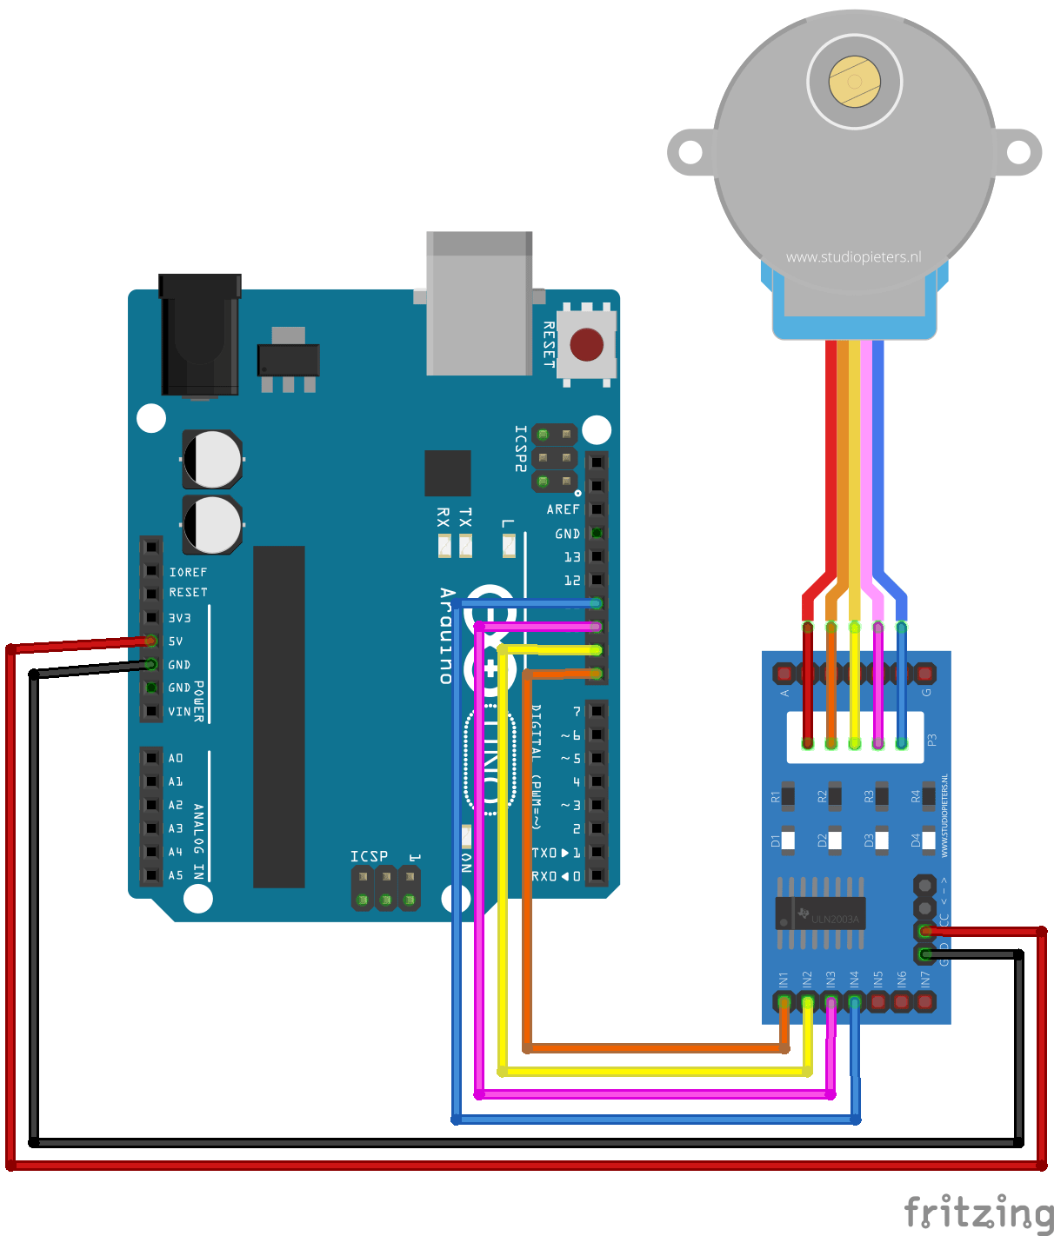

PIN CONNECTIONS

the four coils of the stepper motor we are using the digital pins 8,9,10 and 11. The driver module is powered by the 5V pin of the Arduino Board.

But, power the driver with External Power supply when you are connecting some load to the steppe motor. Since I am just using the motor for demonstration purpose I have used the +5V rail of the Arduino Board. Also remember to connect the Ground of the Arduino with the ground of the Diver module.

WORKING

we will have to make 2048 steps to make one complete rotation, so when we enter 2048 the motor will make one complete rotation in clockwise direction by making 2048 steps. To rotate in anti-clockwise just enter the number with “–“negative sign. So, entering -1024 will make the motor to rotate half the way in anti-clock wise direction. You can enter any desired values, like entering 1will make the motor to take only one step.

CODE

int motorPin1 = 8;

int motorPin2 = 9;

int motorPin3 = 10;

int motorPin4 = 11;

int delayTime = 150;

void setup() {

pinMode(motorPin1, OUTPUT);

pinMode(motorPin2, OUTPUT);

pinMode(motorPin3, OUTPUT);

pinMode(motorPin4, OUTPUT);

}

void loop() {

digitalWrite(motorPin4, HIGH);

digitalWrite(motorPin3, LOW);

digitalWrite(motorPin2, LOW);

digitalWrite(motorPin1, LOW);

delay(delayTime);

digitalWrite(motorPin4, LOW);

digitalWrite(motorPin3, HIGH);

digitalWrite(motorPin2, LOW);

digitalWrite(motorPin1, LOW);

delay(delayTime);

digitalWrite(motorPin4, LOW);

digitalWrite(motorPin3, LOW);

digitalWrite(motorPin2, HIGH);

digitalWrite(motorPin1, LOW);

delay(delayTime);

digitalWrite(motorPin4, LOW);

digitalWrite(motorPin3, LOW);

digitalWrite(motorPin2, LOW);

digitalWrite(motorPin1, HIGH);

delay(delayTime);

}

